Good Afternoon Huron Band Families!!

There have been a lot of questions and changes regarding Band Camp at Huron this year; hopefully this synopsis will provide some answers, and a glimpse to what we are planning.

Our in-person Band Camp was tentatively scheduled to take place August 17-22, but the AAPS Administration and Music Faculty have decided that in our current climate, an in-person camp is no longer safe for our students.

In its stead, we will host a Virtual Camp designed by our directors, student leaders, and alumni. We will have regular sectionals, traditional band camp activities (i.e. Rat Races), Drum Major Auditions, and Camp Awards. The camp will be run by a group of alumni councilors and our directors.

The tentative schedule for camp is as follows:
Wednesday, August 19th - 11am - 1pm [Sectionals: 11am-12pm] [Camp Activity 1: 12pm-1pm]
Thursday, August 20th - 11am - 1pm [Sectionals: 11am-11:30am] [Camp Activity 2: 11:30am-1pm]
​
Friday, August 21st - 11am - 1pm [Sectionals: 11am-11:30am] [Camp Activity 2: 11:30am-1pm]
Saturday, August 22nd - [Drum Major Auditions: 11am – 12:45pm] [Camp Awards 2:00pm - 3:00pm]

The deadline to register for camp is this Monday, August 17th. Please see the Huron Bands Website for all information regarding camp and the registration process. This is a highly recommended experience for all members of the Huron Bands (It is open for students in Symphony Band, Concert Green, Concert Gold, and Varsity Band). This is especially valuable for in-coming 9th grade Huron Band members. It will be an excellent opportunity for our in-coming students to connect with our supportive band family.

There is no cost to participate in our virtual camp, but there are cost to run this experience, as well as costs to run this year’s marching season. Please consider donating your in-person band camp fee or offer a donation to our program to help run this experience. Additionally, we will be offering 2020-21 band t-shirts for $10. More information can be found in the online registration form.

Student Leadership: Our student leadership will be announced ASAP. Our leaders will consist of Huron Band Board members (some already selected), squad leaders, and drum major candidates. The members will receive an email next week ASAP. Those members will have a leadership training session on Sunday, Aug 16th from 6pm - 8pm online. If you receive an invitation, please RSVP as soon as possible.

This is a lot of information, so if you have any questions, or concerns please feel free to let me know by emailing me at Mr. Ash

Thank you for helping us keep everyone safe!

All the Best,
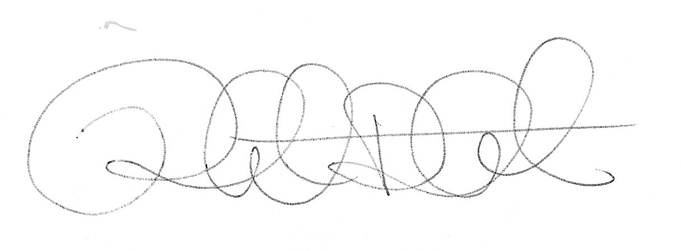
Robert Ash
Director of Bands
Ann Arbor Huron High School
Ann Arbor, MI

